Name: Kamal Agrahari Lab: DevOps

ID: VU4F2223028 TE | IT | A

**Experiment No. 12 Title:** Demonstration of ansible automation.

# Theory:

**Ansible** is an open-source automation tool that simplifies the process of configuration management, application deployment, and task automation across a network of machines. It uses a simple and human-readable language (YAML) for writing automation scripts called **playbooks**. This demonstration outlines the steps to automate a basic task using Ansible.

## Objective

In this demonstration, we will automate the installation of **Nginx** on multiple remote servers using Ansible.

## Prerequisites

1. **Ansible Installed**: Ensure Ansible is installed on your control machine (the machine from which you will run Ansible).
2. **SSH Access**: Ensure that you have SSH access to the target machines and that they are listed in the Ansible inventory file.
3. **Target Machines**: Have at least two target machines (remote servers) ready for Nginx installation.

Steps to follow:

Step 1: Create an inventory file (hosts.ini) to define the target machines. This file specifies the IP addresses or hostnames of the servers where you want to deploy Nginx.

[webservers]

server1 ansible_host=192.168.1.10 server2 ansible_host=192.168.1.11

**Step 2:** Create a playbook file (install_nginx.yml) to describe the tasks needed to install Nginx. This playbook will include tasks for installing Nginx and starting the service.

---

- name: Install Nginx on web servers hosts: webservers

become: yes # Use sudo to install packages tasks:

- name: Update package manager cache apt:

update_cache: yes

- name: Install Nginx apt:

name: nginx state: present

- name: Start Nginx service service:

name: nginx state: started enabled: yes

**Step 3:** To execute the playbook and install Nginx on the target servers, run the following command in your terminal:

ansible-playbook -i hosts.ini install_nginx.yml

**Step 4:** After running the playbook, you can verify that Nginx is installed and running on the target servers. SSH into one of the servers and run:

systemctl status nginx

Ansible to automate the installation of Nginx on multiple servers. By defining the target servers in an inventory file and outlining the installation steps in a playbook, we simplified the deployment process, ensuring consistency and reducing manual effort. Ansible’s ability to manage multiple systems simultaneously makes it an invaluable tool for system administrators and DevOps engineers.

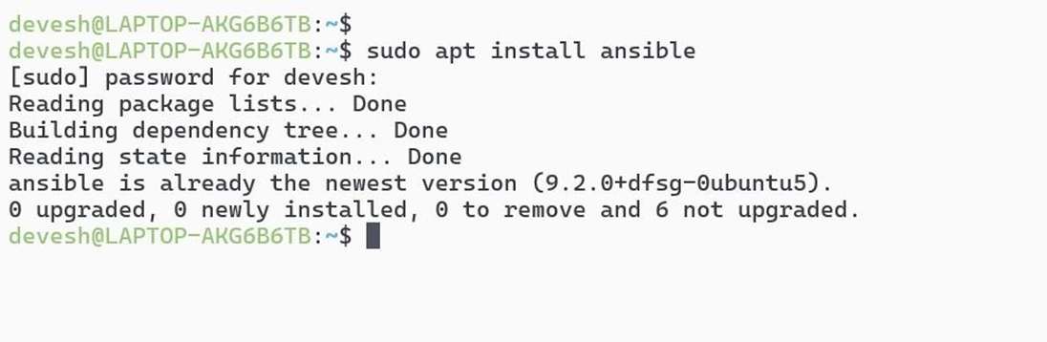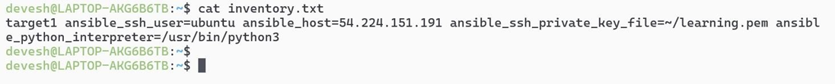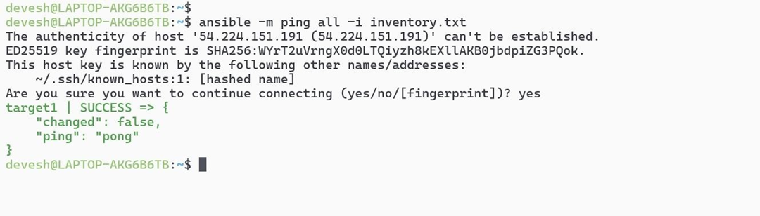

# Conclusion:

Hence, we have successfully demonstrate an ansible automation